CUSTOMER CHURN ANALYSIS REPORT

1. Project Overview

A telecom company needed to understand who leaves, when they leave, and why they leave — to reduce customer churn, improve retention, and protect revenue.

"How can the company leverage customer subscription data to identify churn drivers, segment high-risk customers, and design data-backed retention strategies?"

2. Dataset Summary
- Rows: 7,043 customer records
- Columns: 21 features
- Source: Kaggle — Telco Customer Churn
- Missing Data: 11 blank values in TotalCharges column → imputed with MonthlyCharges
Feature Type | Columns
Demographics | Gender, Senior Citizen, Partner, Dependents
Subscription Info | Contract Type, Internet Service, Phone Service, Streaming
Add-on Services | Tech Support, Online Security, Online Backup, Device Protection
Billing | Monthly Charges, Total Charges, Payment Method, Paperless Billing
Behavior | Tenure (months), Churn (Yes/No)

3. Data Cleaning & Analysis (Python)
We began with data preparation and cleaning in Python:
- Data Loading: Imported the dataset using pandas.
- Missing Data Fix: Converted blank TotalCharges strings to numeric; imputed 11 null values with MonthlyCharges.
- Column Standardization: Renamed all columns to snake_case for better readability and documentation.
- Binary Encoding: Created churn_flag column (Yes → 1, No → 0) for aggregation and analysis.
- Feature Engineering: Created tenure_group column — binned tenure into 6 cohorts (0-12 month, 13-24 month, 25-36 month, 37-48 month, 49-60 month, 61-72 month).
- Cohort Analysis: Built retention heatmap — churn rate by tenure group × contract type.
- EDA Charts: Created visualizations for churn by contract type, payment method, internet service, add-on services, and tenure group.
- Revenue Calculation: Quantified annual revenue at risk from churned customers.
- High-Risk Segment: Identified month-to-month + fiber optic + no tech support segment (58% churn rate).
- Database Integration: Exported cleaned DataFrame to MySQL database for SQL analysis.

4. Data Analysis (SQL)
1. Overall Churn KPIs — the executive summary numbers
SELECT
COUNT(customerid) AS total_customers,
SUM(churn_flag) AS total_churned,
COUNT(customerid) - SUM(churn_flag) AS total_retained,
ROUND(SUM(churn_flag) * 100.0 / COUNT(customerid), 2) AS churn_rate_pct,
ROUND(AVG(monthlycharges), 2) AS avg_monthly_charges,
ROUND(SUM(churn_flag * monthlycharges), 2) AS monthly_revenue_at_risk,
ROUND(SUM(churn_flag * monthlycharges) * 12, 2) AS annual_revenue_at_risk
FROM telco_churn_data;

2. Churn Rate by Contract Type
SELECT
contract,
COUNT(customerid) AS total_customers,
SUM(churn_flag) AS churned,
ROUND(SUM(churn_flag) * 100.0 / COUNT(customerid), 2) AS churn_rate_pct,
ROUND(AVG(monthlycharges), 2) AS avg_monthly_charges,
ROUND(SUM(churn_flag * monthlycharges) * 12, 2) AS annual_rev_at_risk
FROM telco_churn_data
GROUP BY contract
ORDER BY churn_rate_pct DESC;
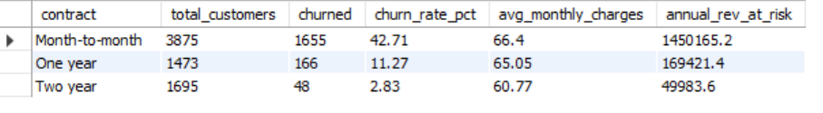
3. Avg Monthly Charges — Churned vs Retained
SELECT
churn AS churn_status,
COUNT(customerid) AS customers,
ROUND(AVG(monthlycharges), 2) AS avg_monthly_charges,
ROUND(MIN(monthlycharges), 2) AS min_monthly_charges,
ROUND(MAX(monthlycharges), 2) AS max_monthly_charges,
ROUND(AVG(totalcharges), 2) AS avg_total_charges,
ROUND(AVG(tenure), 1) AS avg_tenure_months
FROM telco_churn_data
GROUP BY churn
ORDER BY churn DESC;
4. High-Risk Customer Segment
SELECT
COUNT(customerid) AS segment_size,
SUM(churn_flag) AS churned,
ROUND(SUM(churn_flag) * 100.0 / COUNT(customerid), 2) AS segment_churn_rate_pct,
ROUND(SUM(churn_flag * monthlycharges) * 12, 2) AS annual_rev_at_risk,
ROUND(AVG(monthlycharges), 2) AS avg_monthly_charges,
-- Benchmark vs overall churn rate
(SELECT ROUND(SUM(churn_flag) * 100.0 / COUNT(customerid), 2)
FROM telco_churn_data) AS overall_churn_rate_pct
FROM telco_churn_data
WHERE contract = 'Month-to-month'
AND internetservice = 'Fiber optic'
AND techsupport = 'No'
AND onlinesecurity = 'No';
5. Revenue at Risk
SELECT
contract,
internetservice,
COUNT(customerid) AS total_customers,
SUM(churn_flag) AS churned_customers,
ROUND(SUM(churn_flag) * 100.0 / COUNT(customerid), 2) AS churn_rate_pct,
ROUND(SUM(churn_flag * monthlycharges), 2) AS monthly_rev_lost,
ROUND(SUM(churn_flag * monthlycharges) * 12, 2) AS annual_rev_lost
FROM telco_churn_data
GROUP BY contract, internetservice
ORDER BY annual_rev_lost DESC;
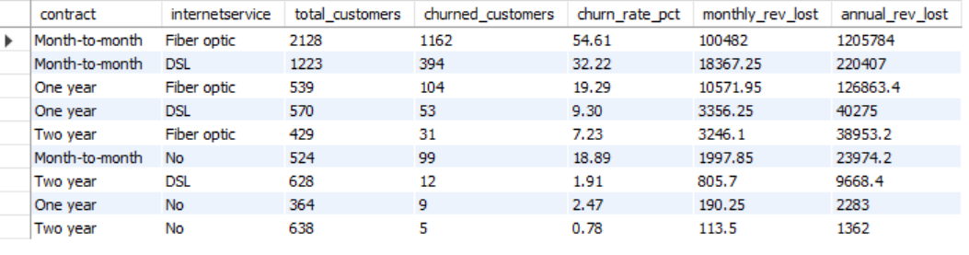
6. Customers with >24 Months Tenure Who Still Churn
SELECT
contract,
internetservice,
paymentmethod,
COUNT(customerid) AS long_tenure_churners,
ROUND(AVG(tenure), 1) AS avg_tenure_months,
ROUND(AVG(monthlycharges), 2) AS avg_monthly_charges,
ROUND(AVG(totalcharges), 2) AS avg_total_charges,
ROUND(SUM(monthlycharges) * 12, 2) AS annual_rev_lost
FROM telco_churn_data
WHERE tenure > 24
AND churn_flag = 1
GROUP BY contract, internetservice, paymentmethod
ORDER BY long_tenure_churners DESC;

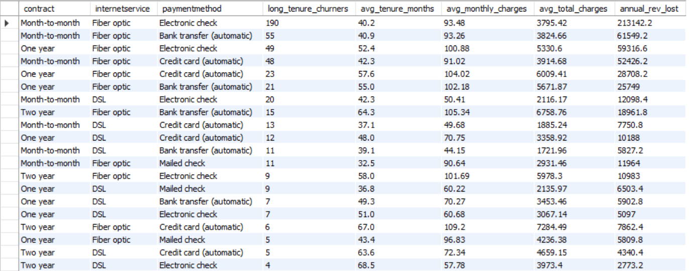

7. Churn Rate by Payment Method
SELECT
paymentmethod,
COUNT(customerid) AS total_customers,
SUM(churn_flag) AS churned,
ROUND(SUM(churn_flag) * 100.0 / COUNT(customerid), 2) AS churn_rate_pct,
ROUND(AVG(monthlycharges), 2) AS avg_monthly_charges
FROM telco_churn_data
GROUP BY paymentmethod
ORDER BY churn_rate_pct DESC;
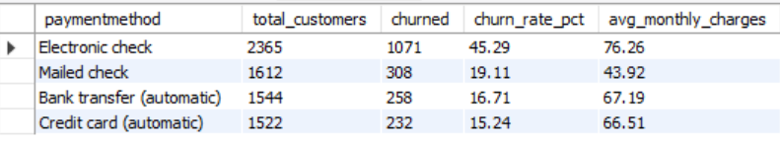
8. Impact of Add-on Services on Churn
SELECT
techsupport,
onlinesecurity,
COUNT(customerid) AS customers,
SUM(churn_flag) AS churned,
ROUND(SUM(churn_flag) * 100.0 / COUNT(customerid), 2) AS churn_rate_pct,
ROUND(AVG(monthlycharges), 2) AS avg_monthly_charges
FROM telco_churn_data
WHERE internetservice != 'No' -- only customers with internet
GROUP BY techsupport, onlinesecurity
ORDER BY churn_rate_pct DESC;
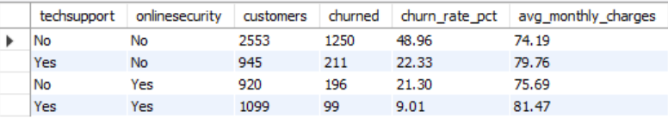
9. Churn by Tenure Group with Revenue Impact
SELECT
CASE
WHEN tenure BETWEEN 0 AND 12 THEN '0–12 mo'
WHEN tenure BETWEEN 13 AND 24 THEN '13–24 mo'
WHEN tenure BETWEEN 25 AND 36 THEN '25–36 mo'
WHEN tenure BETWEEN 37 AND 48 THEN '37–48 mo'
WHEN tenure BETWEEN 49 AND 60 THEN '49–60 mo'
ELSE '61–72 mo'
END AS tenure_group,

COUNT(customerid) AS total_customers,
SUM(churn_flag) AS churned,
ROUND(SUM(churn_flag) * 100.0 / COUNT(customerid), 2) AS churn_rate_pct,
ROUND(AVG(monthlycharges), 2) AS avg_monthly_charges,
ROUND(SUM(churn_flag * monthlycharges) * 12, 2) AS annual_rev_at_risk

FROM telco_churn_data
GROUP BY
CASE
WHEN tenure BETWEEN 0 AND 12 THEN '0–12 mo'
WHEN tenure BETWEEN 13 AND 24 THEN '13–24 mo'
WHEN tenure BETWEEN 25 AND 36 THEN '25–36 mo'
WHEN tenure BETWEEN 37 AND 48 THEN '37–48 mo'
WHEN tenure BETWEEN 49 AND 60 THEN '49–60 mo'
ELSE '61–72 mo'
END
ORDER BY MIN(tenure);
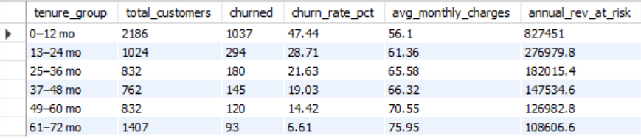

10. Top 3 Churning Profiles Using Window Function
WITH profile_churn AS (
SELECT
contract,
internetservice,
techsupport,
paymentmethod,
COUNT(customerid) AS total_customers,
SUM(churn_flag) AS churned,
ROUND(SUM(churn_flag) * 100.0 / COUNT(customerid), 2)
AS churn_rate_pct,
ROUND(SUM(churn_flag * monthlycharges) * 12, 2) AS annual_rev_at_risk
FROM telco_churn_data
GROUP BY contract, internetservice, techsupport, paymentmethod
HAVING COUNT(customerid) >= 50 -- exclude tiny segments
),
ranked AS (
SELECT
*,
ROW_NUMBER() OVER (ORDER BY churn_rate_pct DESC) AS risk_rank
FROM profile_churn
)
SELECT
risk_rank,
contract,
internetservice,
techsupport,
paymentmethod,
total_customers,
churned,
churn_rate_pct,
annual_rev_at_risk
FROM ranked
WHERE risk_rank <= 10
ORDER BY risk_rank;
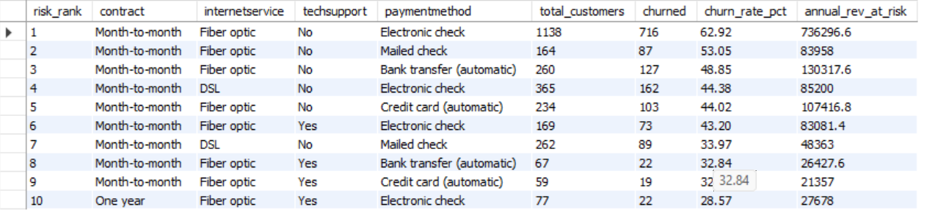

5. Exploratory Insights :

Insight | Finding
👥 Total Customers | 7,043 customers analyzed
📉 Overall Churn Rate | 26.5% of customers churned
📋 Churned Customers | 1,869 customers lost
💰 Annual Revenue at Risk | ~$1.67M in yearly recurring revenue at risk
🔴 Highest Risk Contract | Month-to-month — 42.7% churn rate
✅ Lowest Risk Contract | Two year — 2.8% churn rate
⚡ Highest Risk Service | Fiber optic — 41.9% churn rate
🛡️ Best Retention Add-on | Tech Support + Online Security — cuts churn by ~50%
💳 Riskiest Payment Method | Electronic check — 45.3% churn rate

6. Dashboard (Power BI)
Page 1 — Executive Summary: 4 KPI cards, contract type slicer, internet service slicer, churn rate by contract type (bar chart), churn rate by payment method (bar chart).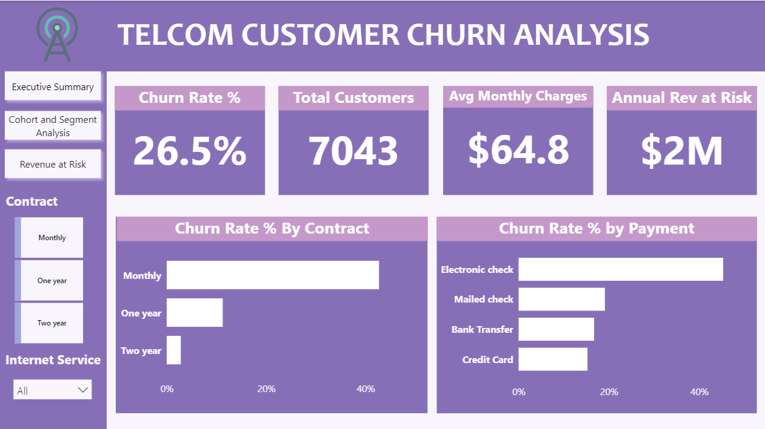
Page 2 — Cohort & Segment Analysis: Cohort heatmap showing churn rate by tenure group × contract type. Churn rate by tenure line chart. Tech support vs churn bar chart.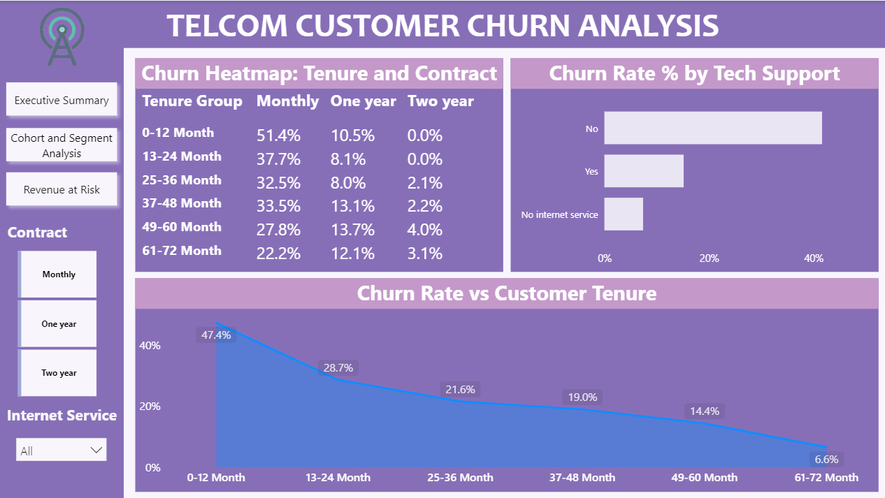
Page 3 — Revenue at Risk: Annual revenue at risk by contract type (bar chart). Churned customers by internet service (donut chart). Revenue at risk treemap.
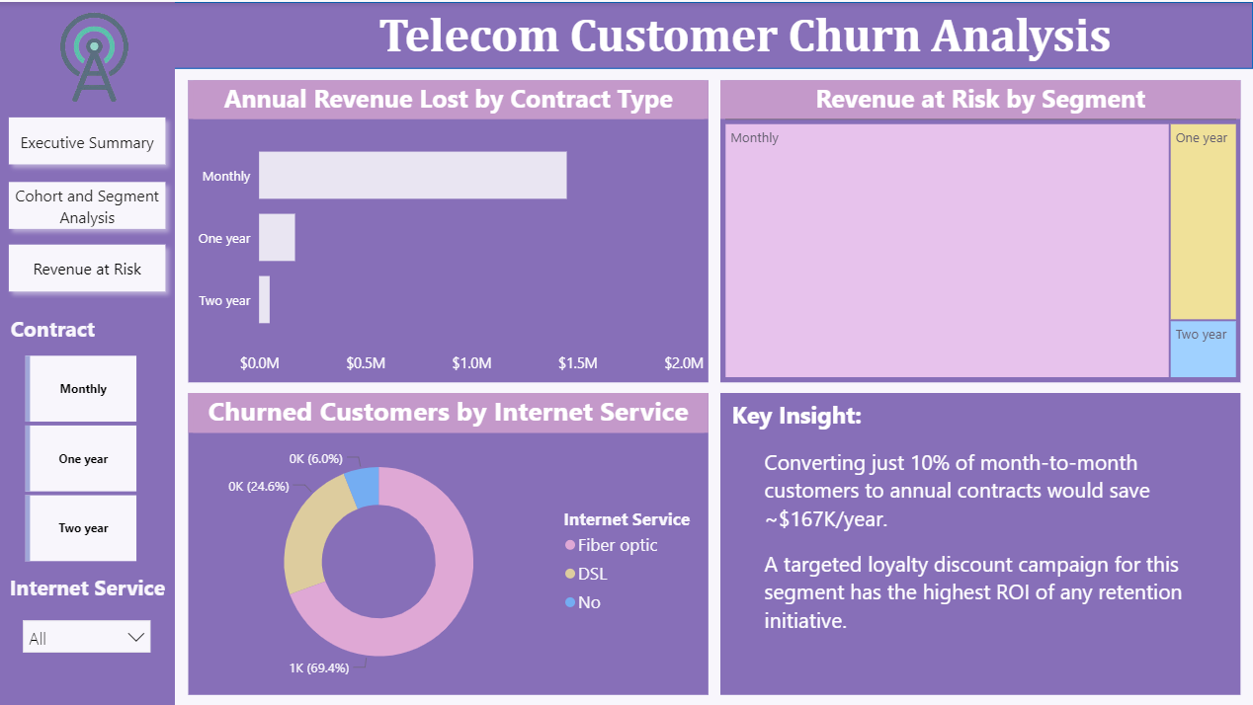

7. Business Recommendations
1. Convert Month-to-Month Customers to Annual Contracts
Month-to-month customers churn at 42.7% vs 2.8% for two-year contracts. Offer 1-2 months free or a loyalty discount to drive annual plan upgrades. Converting just 10% of this segment saves ~$167K/year.
2. Build a 90-Day Onboarding Program
Customers in their first 12 months churn at 47.7% — the highest of any cohort. Assign dedicated onboarding support, proactive check-ins, and a free tech support trial for all new customers.
3. Bundle Tech Support + Online Security
Customers with both add-ons churn at ~15% vs ~41% for those with neither. Offer a "Protection Bundle" free for the first 3 months to fiber optic customers — the highest-risk service group.
4. Migrate Electronic Check Users to Auto-Pay
Electronic check customers churn at 45.3% vs 15-17% for auto-pay users. Offer a small monthly discount (e.g., 5%) to incentivize switching to automatic bank transfer or credit card payment.
5. Target Long-Tenure Month-to-Month Customers
2+ year customers still on month-to-month contracts are high-value retention targets. They stayed long enough to show loyalty but never upgraded. A personalized loyalty offer for this segment has the highest conversion potential.
6. Proactively Re-Engage Repeat Buyers Without Subscriptions
2,518 customers with 5+ purchases are not subscribed. A targeted re-engagement campaign — email, in-app notification, or a call — focused on this group has direct revenue upside with low acquisition cost.

This project was completed as part of a telecom customer behavior analysis initiative using Python, SQL, and Power BI.

